**Tugas week 11 advanced bda Christopher Darren 00000054804**

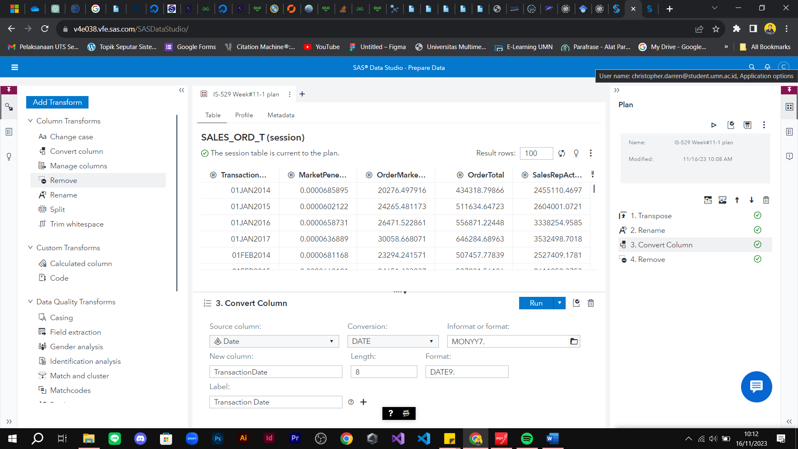

Figure A

QUIZ

1. How many columns are in the source table?

**Answer: 9 Columns**

1. Give your answer in a circle like the example picture on figure B and save your screenshot.

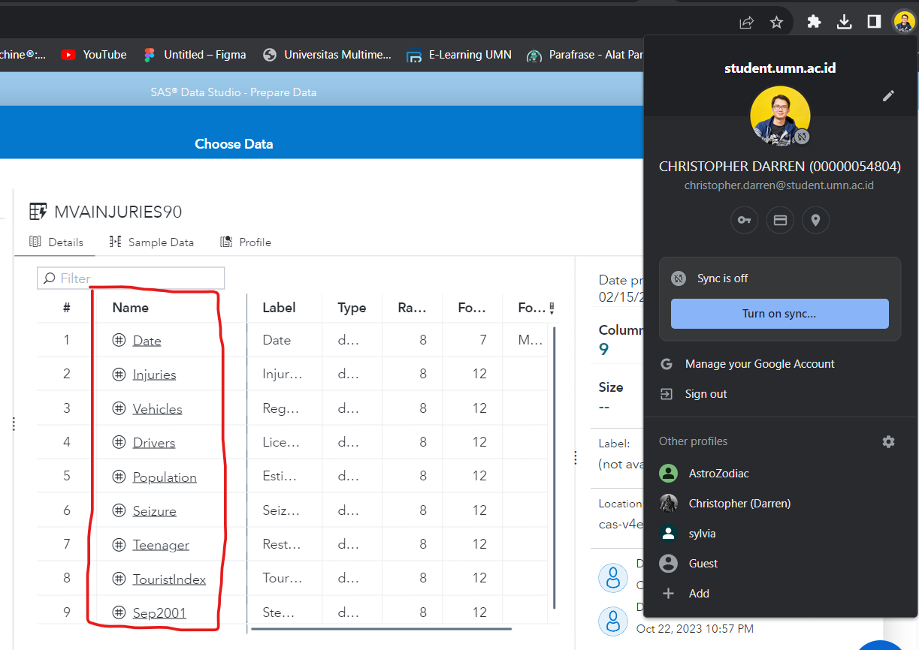

Figure B

1. How many columns are in the MVAINJURIES00 table?

Answer: **9 Columns (before Append)**

1. Give your answer in a circle like the example picture on figure C and save your screenshot.

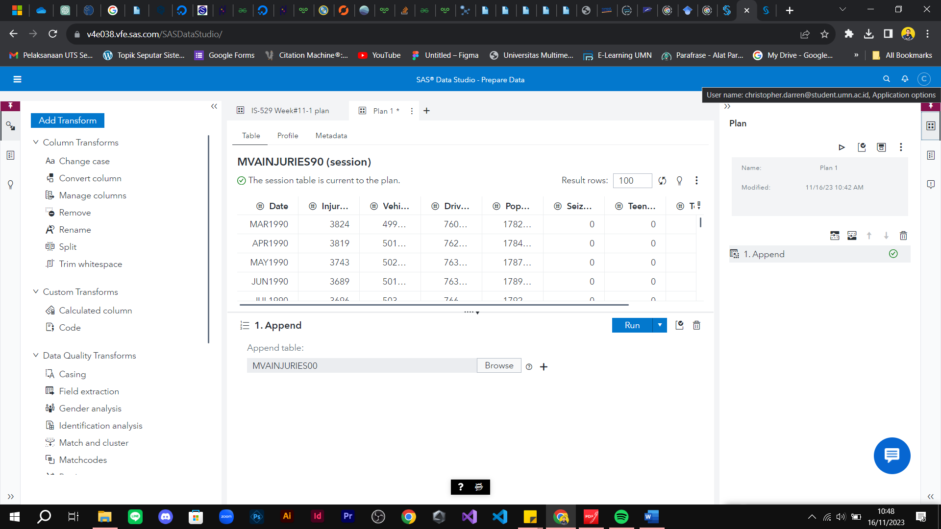

**Before D/V table 9 Columns**

Figure C

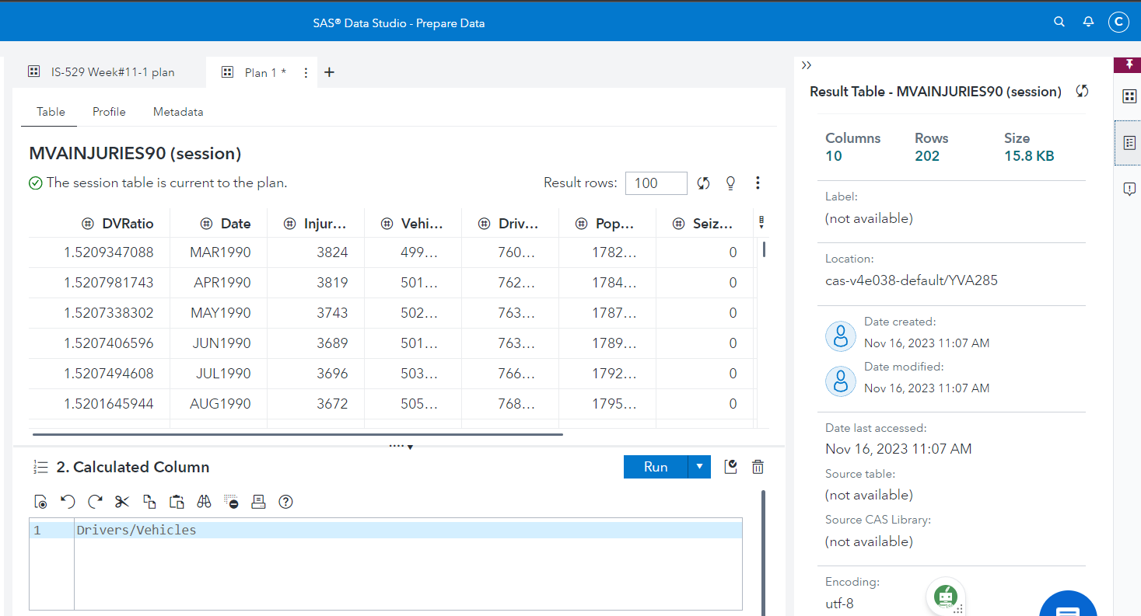

**After append DVcolumn 10 Columns**

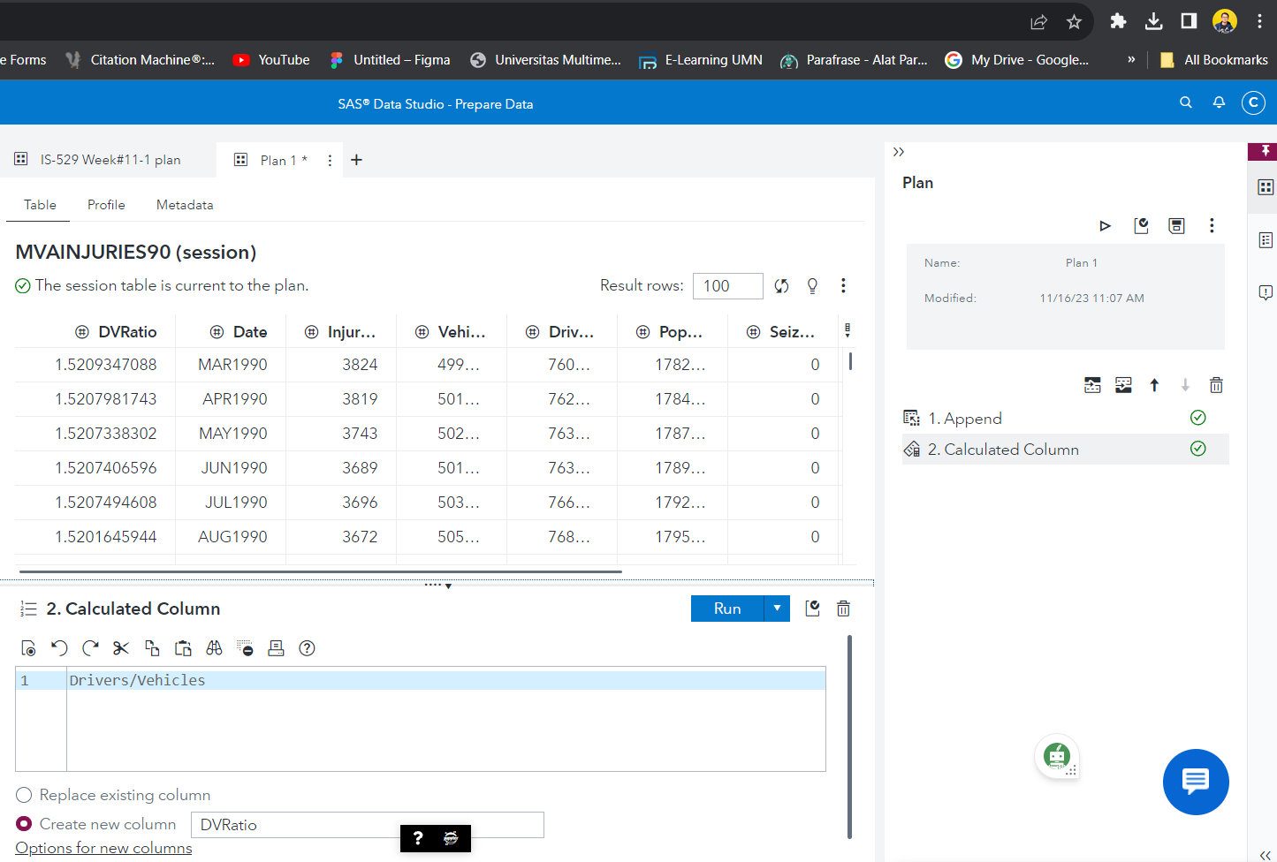

**Calculations**

Figure D